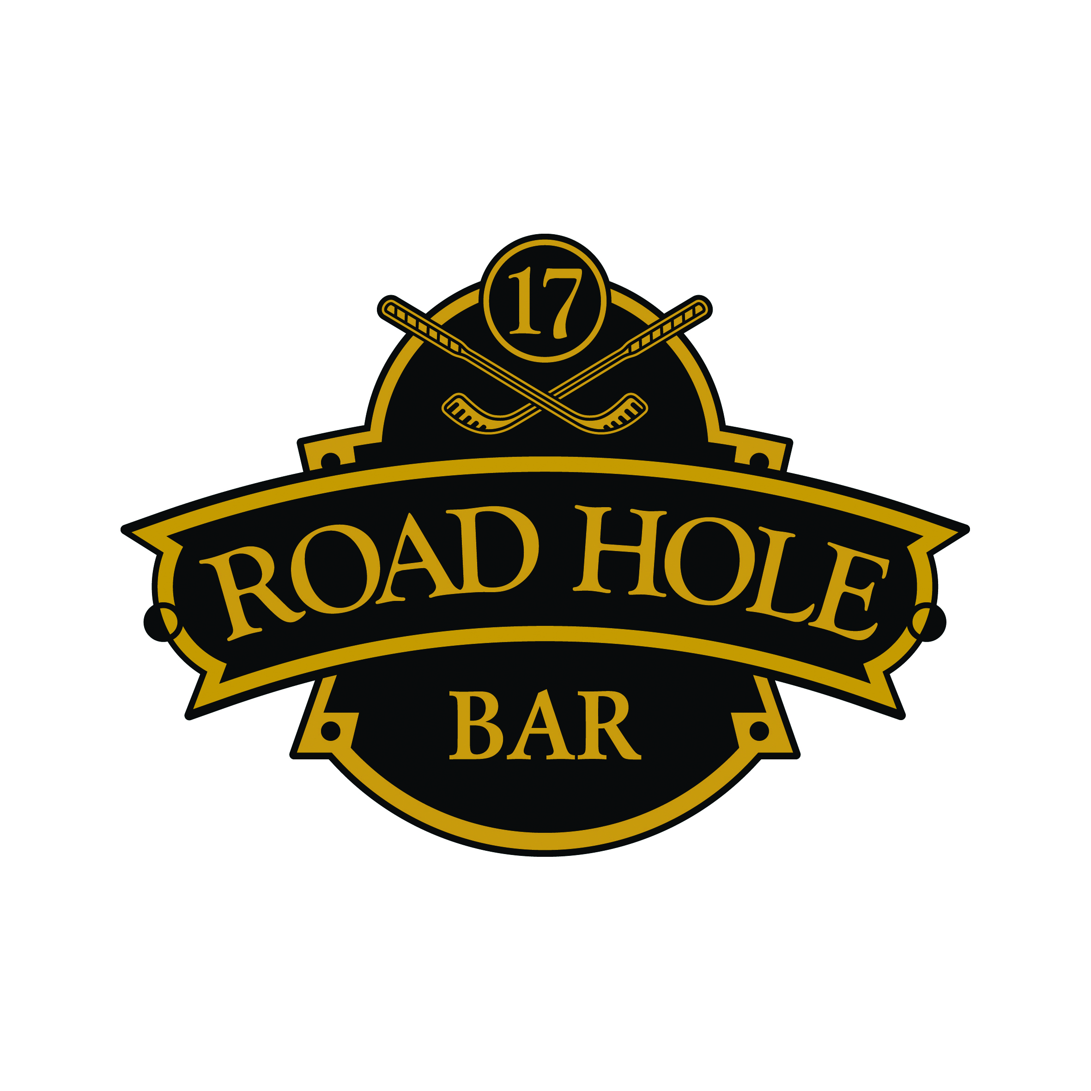

Welcome to
The Road Hole Bar

In your view lies the world famous Road Hole; the par-4 17th of The Old Course and one of the most challenging holes in the game of Golf.
From a blind tee shot, players must hit over The Hotel and avoid a notorious bunker protecting the green. Overcook it and over the back of the green you will be greeted with hazards including a tarmac road and an old stone wall. Both are in play; a wayward shot can lead a player to take their next stroke off the road or to hit the face of the wall and take their chances with the ensuing bounce

“If you designed the hole now you would be shot. If you said now 'I'm going to put a tee over an old railway and get you to hit over a hotel', people would think you were off your head.”

Colin Montgomerie

Champagne Selection

 |  |  |  |  |  |  |  |  |  | Glass 125ml |  |  | Bottle
 |  |  | Non-Vintage Champagne
001 |  | Deutz, Brut Classic |  |  |  |  |  |  | £10 |  |  |  | £59.00
005 |  | Veuve Cliquot-Ponsardin, Brut |  |  |  |  |  |  |  |  |  |  | £75.00
007 |  | Bollinger Special Cuvee, Brut |  |  |  |  |  |  |  |  |  |  | £75.00
003 |  | Taittinger Reserve, Brut |  |  |  |  |  |  |  |  |  |  | £60.00
 |  |  | Vintage Champagne
024 |  | Pommery ‘’Louise’’, Brut 1998 |  |  |  |  |  |  |  |  |  |  | £125.00
023 |  | Dom Perignon, 2005 |  |  |  |  |  |  |  |  |  |  | £250.00
017 |  | Krug, 1990 |  |  |  |  |  |  |  |  |  |  | £450.00
 |  |  | Rosé
031 |  | Deutz Rosé |  |  |  |  |  |  | £14.50 |  |  | £86.00

“I drink it when I'm happy and when I'm sad.
Sometimes I drink it when I'm alone.
When I have company I consider it obligatory.
I trifle it when I'm not hungry and I drink it when I am.
Otherwise I never drink it – unless I'm thirsty!”

Madame Jacques Bollinger,
17th October 1961.

Wines by the Glass

 |  |  | Glass  125ml | Bottle  750ml
White
181 | Chardonnay  “Ultra”, Kaiken Winery,  Mendoza, Argentina |  | £7.50 | £43.00
133 | Gavi la Conchetta  Araldica,  Piedmont, Italy |  | £5.50 | £31.00
124 | Seculo Godello  Vinos de Arganza, Bierzo |  | £5.00 | £29.00
158 | Sauvignon Blanc  Tinpot Hut,  Marlborough, New Zealand |  | £6.00 | £35.00
Rosé
193 | Château Riotor  Côtes de Provence,  France |  | £5.50 | £32.50
Red
322 | Barbera d’Asti  Ceppi Storici,  Piedmont, Italy |  | £5.00 | £30.00
376 | Merlot  Sepia Reserve, Vistamar,  Central Valley, Chile |  | £5.50 | £31.00
398 | Polo Malbec  Finca la Chamiza,  Mendoza, Argentina |  | £6.25 | £35.00
207 | Château Cissac  Haut Médoc,  Bordeaux, France |  | £ £8.00 | £46.00

“Nothing more excellent or valuable than wine has ever been granted by the gods to men.”

Plato

Old Fashions

Old Course Hotel Signature Old Fashioned £9.50
The perfect and Famous Old Fashioned with Glenmorangie Original.
Young Laddie £10.00
Bruichladdich Laddie 10, angostura bitters and orange twist.

Old Fashioned £10.00
Possibly one of the best cocktails ever created. Woodford Reserve Bourbon, built up over ice with brown sugar and Aromatic bitters.
Good things come to those who wait.

The Bartender £13.00
A variation on the Old-Fashioned cocktail concocted by Robert Simonson, illustrious author of ‘’The Old-Fashioned’’, that uses Fernet-Branca with Woodford Reserve to keep this classic interesting.

Islay Old Fashioned £19.00
A combination of Lagavulin 16 and Peychaud’s bitters perfumed with fresh lemon zest.

Old Course Happy Hour £13.00
Eden Mill love gin, raspberry bitters garnished with frozen raspberries.

Chai Honey Old Fashioned £10.00
Woodford Reserve Bourbon and Chai tea infusion, dash of fresh orange juice, honey and bitters.

Desert Rose £13.00
Tequilla, Mezcal and Agave syrup! A spicy old fashion.

Our Favourites

Rossini £9.00
Prosecco and strawberry purée.

Caipirinha £10.00
Named Brazil’s national cocktail made popular by its
Medicinal history and refreshing clean flavours.
Muddled fresh limes with sugar and Sagatiba Cacacha Pura.

Bramble £10.00
Royalty amongst the British cocktail scene for a reason,
Vibrant, floral and refreshing. Bombay, Crème de
Mure and Fresh Lemon Juice.

Planter’s Punch £10.00
A celebration of all things tropical, simple ingredients with a surprising depth of flavour. Gosling’s Black Seal rum, pineapple,
Orange and lime juice with a splash of Grenadine. A beautiful
Drink well deserving of a revival.

Brandy Alexander £10.00
This classic after dinner cocktail is made with Courvoisier VSOP cognac, crème de cacao brown giving you a hint of chocolate, and cream to just finish it off. Garnished with freshly grated nutmeg. A dessert in a glass.

Dark ‘n’ Stormy £10.00
A classic brought to life with homemade fiery ginger syrup, Gosling’s Black Seal rum, lime juice and ginger beer.

Mango & Passion Fruit Collins £10.00
Bombay gin with mango and passion fruit purée, lemon juice and sugar, served long with soda. Fruity, sweet and refreshing.

Bellini £9.00
Peach puree & Prosecco, blended with crushed ice, topped with a little more Prosecco.

Classic Champagne Cocktail £16.50
Deutz Brut Classic, Courvoisier VSOP, brown sugar cube soaked with angustura bitters.

Our Bartenders’ Perfect Serves

French Kiss £10.00
Fruity, floral and fizzy, what more could you want? Elderflower liqueur, rose liqueur and lemon juice topped with Prosecco.

Bloody Mary £10.00
The best in town - our own recipe Bloody Mary mix with Chilli Stolichnaya vodka, fresh tomato juice, celery and lemon.

The Perfect Botanist £11.00
An artisanal Islay gin brought from the Bruichladdich
Distillery, served long with apple blossom and Fever Tree
tonic water.

Ginger Spritz £10.00
Belvedere Vodka, Antica Formula topped up with soda and tonic. Garnished with fresh ginger root and a slice of orange.

Hennessey XO Riviera £25.00
A modern and refreshing serve of Hennessey XO over ice, with a splash of sparkling water.

Perfect Chilli Gin Bothy £13.00
Gin Bothy Chilli garnished with chocolate, chilli & mint. Served long with lemonade.

Tanqueray Ten Martini £16.00
One for the gin lovers, Tanqueray Ten stirred with an infusion of
Lillet Blanc, chamomile and grapefruit. Playing on the fresh fruit botanicals found in the gin itself. An unusual martini served in an unusual glass...

“I like to drink a martini. Two at the very most. Three I'm under the table, four I'm under the host.”

Dorothy Parker

Whisky Cocktails

Perfect Macallan £10.00
Simply enjoy our MacAllan Gold over large ice cube and lemon zest.

Manhattan £10.00
Jim Beam Rye Whiskey tamed with Antica Formula
and Orange Bitters. Fireworks served straight up...

Islay Sour £12.00
A whisky sour with a twist; sweet and peaty Bowmore 15 year old and a dash of lemon juice softened with Pedro Ximénez Sherry. Finished with an Ardbeg 10 mist.

Godfather £10.00
Created during the 70's in the USA, the Godfather was the favoured cocktail of Marlon Brando. An equal mix of Disaronno and Monkey Shoulder whisky.

Blood and Sand £10.00
One of the best Scottish classic cocktails. Cherry brandy, sweet vermouth, orange and Monkey Shoulder whisky.

The Green Gimlet £10.00
Monkey Shoulder whisky, lime juice and basil. This bright, light recipe comes via Michel Dozois, barsmith supreme in Los Angeles.

Raymon Massey £19.00
Crown royal, ginger syrup and champagne!

Haig Club Dapper’ Tini £15.00
Haig Club whisky, Dark Crème de Cacao and fresh lemon juice. A new world cocktail where the usual rules don’t apply.

Mocktails

Mango Mule £6.00
Fresh Mango purée, ginger ale, fresh lime juice.

Apple Mojito £6.00
Fresh mint, apple and lime juice served over
Crushed ice.

Virgin Mary £6.00
Tomato juice with spices, salt and celery.

Red Berry Breeze £6.00
Cranberry juice, strawberry puree, lime juice and sugar, blended with crushed ice.

Wildcat Cooler £6.00
Fresh blueberries, lemon juice, lemonade.

Tropical Sunset £6.00
Passion fruit puree, fresh passion fruit, pineapple juice, lime juice and sugar syrup.

Shirley Temple £6.00
Ginger ale and grenadine syrup.

Virgin Moscow Mule £6.00
Ginger Beer, Lime and homemade ginger syrup.

Riki Tiki Tavi £6.00
Pineapple juice, fresh lime, coconut milk.

“I feel sorry for the people who don't drink. When they wake up in the morning, that's as good as they're going to feel all day.”

Frank Sinatra

Journeys

Our Journeys offer an excellent opportunity to taste and compare different styles of production. We have created a number of Journeys that cover a range of the Whisky producing regions of Scotland. Additionally, we have created a number of alternative Journeys showcasing the more unusual and rarer offerings.
Each Journey includes three 25ml beverages. They are listed in the suggested order of consumption for the best experience.
Lowland Journey | £28 | Speyside Journey | £24
Littlemill 12yr  Glenkinchie 12yr  Auchentoshan 3-wood |  | Pittyvaich  Balvenie 12yr  Allt-A-Bhainne 91
Highland Journey | £16.50 | Island Journey | £19.50
Deanston 12yr  Glendronach 12yr  Tomatin 12yr |  | Scapa Skiren  Ledaig 10yr  Aaron 10yr
Islay Journey | £20.75 | Tour of Scotland | £20.25
Port Charlotte 7yr  Bunnahabhain 12yr  Laphroaig 10yr |  | Springbank 10yr  Dalwhinnie 15yr  Ardbeg 10yr
Lost Distilleries | £33.50 | Outrageous Journey | £475
Coleburn 1981  Rosebank 12yr  Strathmill 1991  Mexican Journey  Don Julio Blanco  Ocho Extra Anejo  Del Maguey Crema  Juniper Journey  Eden Original  Strathern Oak  Gin Bothy Gunshot | £21.25  £15.95 | Killyloch 1967  Glen Grant 1949  Highland Park 40yr  Molasses Journey  Brugal Blanco  Dark Matter  Diplomatico R.E | £12

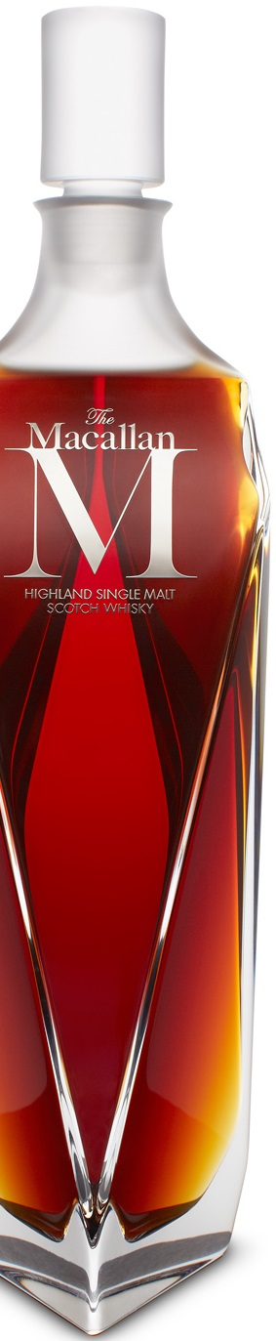

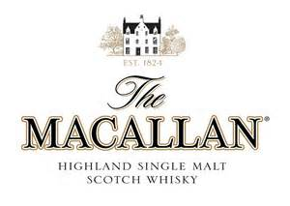

The Macallan M

In a collaboration between three masters of their crafts, The Macallan has unveiled a limited edition luxury decanter, M. Partnering with renowned creative director Fabien Baron and crystal makers Lalique, The Macallan has created a beautifully designed and meticulously crafted crystal decanter containing precious and complex Macallan single malt whisky.

Its six striking facets are Baron’s homage to The Macallan’s heritage, reflecting the six pillars at the heart of its ethos: The Spiritual Home – the breathtaking 390-acre Macallan Speyside estate where M was created; the distillery’s Curiously Small Stills, whose unique shape gives the spirit its fruity, rich character; The Finest Cut, the 16% of the new make spirit, the smallest figure in the industry, selected for maturation; Exceptional Oak Casks, acquired and cared for without thought to the cost, imparting its distinctive characteristics and flavour; Natural Colour created purely through the interaction between spirit and wood; and The Peerless Spirit, marking The Macallan’s unsurpassed place in the hearts of the world’s most discerning whisky drinkers.

Nose
Dried fruits ripen, then soften showing off velvet sateen. Vanilla accompanies green apples hand in hand, neither taking the lead.
Ginger, nutmeg and cinnamon create an ensemble in the background, with polished oak offering to overstate, but never does, but plays with a depth of resinous, juicy oranges.

Palate
The palate opens rich in wood spices, slowly showing all their viscosity. Wood smoke flits in and out.

Finish
The heavier raisin and sultana flavours take over, meandering to a long full finish.

44.7% ABV

50ml - £600
70cl - £5000
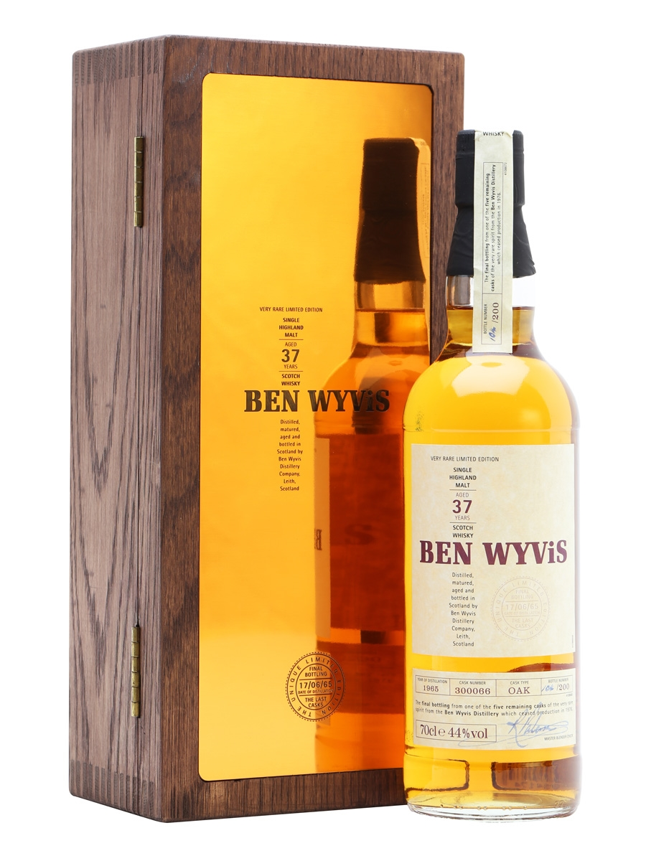
The Ben Wyvis distillery was closed in 1976, just eleven years after it had opened, only a handful of bottlings have ever been released. Having bottled what was believed to be the last casks of Ben Wyvis in 1999 under the name 'The Final Resurrection', Whyte & Mackay were somewhat taken aback to discover that one more cask did in fact exist in their warehouses, and this is the bottling that resulted, probably the very last bottling from one of the shortest-lived distilleries in S
Nose
There are magnificent honeyed notes, gentle herbs and beeswax erupt with palpable intent. Notes of vanilla spice and buttery cream. Menthol, rosewater.

Palate
Rich and the balance is utterly superb with such crystalline clarity, the barley sweetness knows no limits, as does a gentle oak and herbal texture.

Finish
Crisp cereal notes and oaken aridity.

44% ABV

50 ml - £300

Ben Wyvis 37 yr
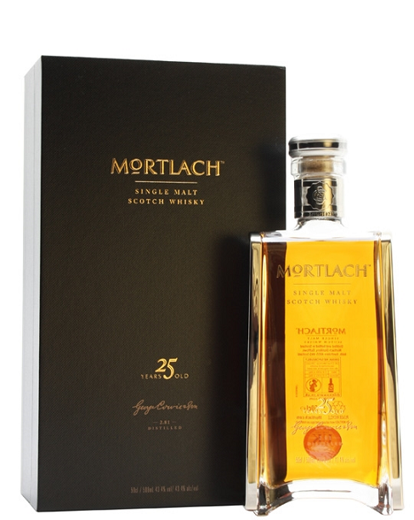
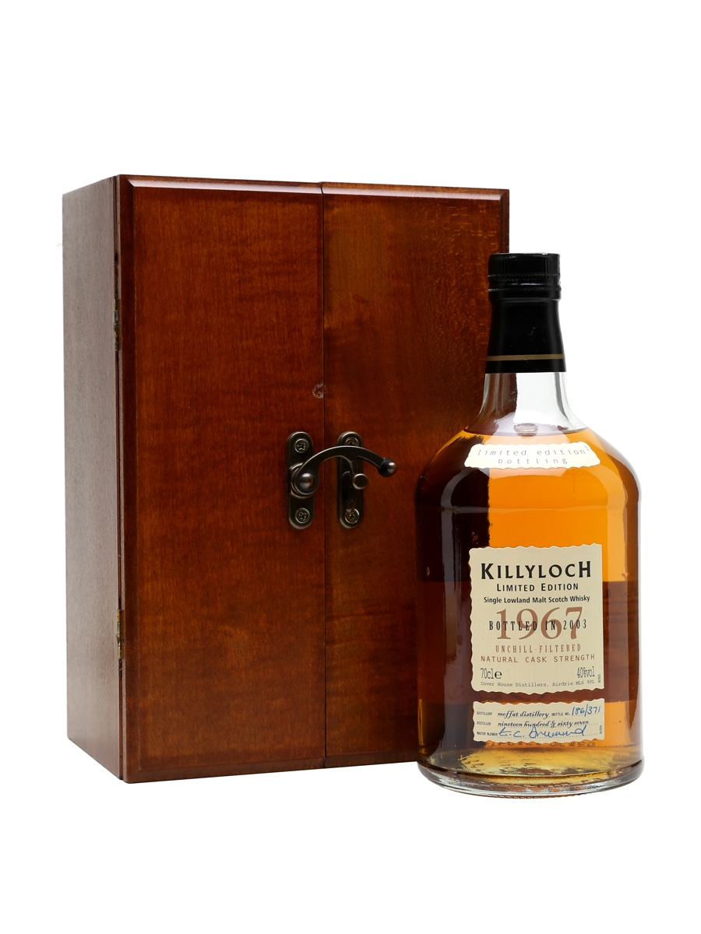
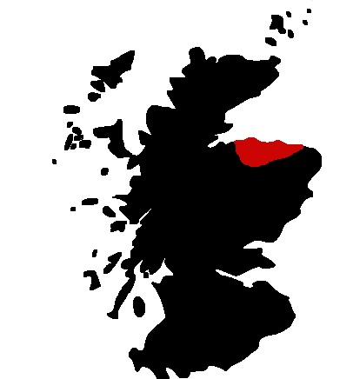
Speyside
The oldest expression from the 2014 release of Mortlach single malt Scotch whiskies is their 25 Year Old. Mortlach use whisky matured mostly in refill American oak casks, aged for a quarter of a century before bottling the whisky into these remarkably designed bottles. Along with the Rare Old, the 18 Year Old and the travel retail exclusive Special Strength, there's now a handsome selection of Mortlach single malts to enjoy - quite a contrast to years previous, when official bottlings were few and far between.
Nose
Vanilla pods, pineapple, lemon zest and a warming hint of tobacco. Touches of crushed almond. Wafts of light oak develop and grow gloriously rich.
Palate
Dark chocolate, oak spice and dried fruits. Baking spices grow on the mid palate, building a rich core alongside the fragrant oak. Subtly herbal further on.
Finish
Sweet, drying notes, highlighted by cocoa and oak spice.

43.4% ABV

50 ml - £195

Mortlach 25 yr
Rarely seen as a single malt, Killyloch was the name for spirit made from a pair of stills at the Moffat complex, which also produced Glen Flagler and Garnheath. Made from the last casks belonging to the distillery's owners, this was distilled in 1967, aged for 36 years and bottled in 2003.
Nose
Medium, tangy citrus. Lemon marmalade and pink grapefruit, verbena freshness.
Palate
Medium intensity, crisp barley. Toasted oak and spices.
Finish
Peppery, spices, oak. Drying

40% ABV

50 ml - £250

Killyloch 1967 yr

Speyside is a small part of the Highland region, located around the river Spey in the northeast of Scotland. Although Speyside is very small, no other region contains more operating distilleries.
Speyside Malts are very rich and complex whiskies with notes of fruits, honey, toffee and chocolate.
Aberlour | 10yr |  | £9.00
Allt-A-Bhainne  Cadenheads – Authentic Collection | 15yr |  | £15.50
Allt-A-Bhainne | 1991 |  | £12.00
Auchroisk  Flora & Fauna Edition | 10yr |  | £12.50
Aultmore  Gordon & MacPhail – Connoisseurs Choice | 1989 |  | £11.50
Balvenie Port Wood | 21yr |  | £28.00
Balvenie Caribean Cask  Balvenie Doublewood | 14yr  12yr |  | £14.00  £12.00
Benriach | 12yr |  | £10.00
Benromach | 10yr |  | £10.00
Braes of Glenlivet  Gordon & MacPhail – Connoisseurs Choice | 1975 |  | £22.00
Braes of Glenlivet  Cadenheads – Authentic Collection | 8yr |  | £16.00
Caperdonich  Gordon & MacPhail – Connoisseurs Choice | 1980 |  | £21.00
Cardhu | 12yr |  | £12.50
Coleburn 1981  Gordon & MacPhail – Connoisseurs Choice | 1981 |  | £25.00
Convalmore  Gordon & MacPhail – Connoisseurs Choice | 1981 |  | £19.00
Cragganmore Distiller's Edition PV | 1993/97 |  | £14.00
Cragganmore | 12yr |  | £10.00
Craigellachie limited | 14yr |  | £25.00
Dailuaine  Flora & Fauna Edition | 16yr |  | £14.00
Dufftown  Gordon & MacPhail – Connoisseurs Choice | 1998/99 |  | £12.00
Dufftown – Singleton of Dufftown | 12yr |  | £11.50
Glen Elgin | 12yr |  | £16.00
Glen Grant | 1949 |  | £325.00
Glen Grant | 10yr |  | £10.00
Glen Spey  Flora & Fauna Edition | 12yr |  | £10.00
Glenallachie  Signatory | 1991/92 |  | £12.00
Glenburgie  Gordon & MacPhail | 8yr |  | £12.00
Glencraig  Gordon & MacPhail – Connoisseurs Choice | 1975 |  | £50.00
Glendullan  Flora & Fauna Edition | 12yr |  | £12.50
Glenfarclas | 25yr |  | £28.50
Glenfarclas | 15yr |  | £12.00
Glenfarclas 105º |  |  | £11.00
Glenfiddich Selection | 21yr |  | £32.00
Glenfiddich Ancient | 18yr |  | £15.00
Glenfiddich Solera | 15yr |  | £12.00
Glenfiddich | 12yr |  | £10.00
Glenkeith | 1983 |  | £18.00
Glenlivet | 18yr |  | £14.00
Glenlivet | 12yr |  | £9.00
Glenlossie | 10yr |  | £12.00
Glenrothes | 1995 |  | £20.00
Glenrothes | 1988 |  | £26.00
Glenrothes Selected Reserve |  |  | £10.00
Glentauchers Limited | 1979 |  | £50.00
Imperial | 1991 |  | £19.00
Imperial  Gordon & MacPhail | 1993 |  | £17.00
Inchgower  Flora & Fauna Edition | 14yr |  | £12.00
Knockando | 12yr |  | £9.00
Linkwood  Regis Whisky Mad | 1992 |  | £14.00
Linkwood | 12yr |  | £18.00
Loch Dhu Black Malt | 10yr |  | £50.00
Longmorn | 16yr |  | £14.00
Macallan Fine Oak Limited | 30yr |  | £300.00
Macallan Sherry | 30yr |  | £350.00
Macallan Sherry | 25yr |  | £195.00
Macallan Fine Oak | 21yr |  | £80.00
Macallan Sherry | 18yr |  | £37.50
Macallan M |  |  | £600.00
Macallan No.6 |  |  | £495.00
Macallan Reflexion |  |  | £200.00
Macallan Rare Cask |  |  | £60.00
Macallan Sienna |  |  | £21.00
Macallan Amber |  |  | £14.00
Macallan Gold |  |  | £10.00
Mannochmore  Flora & Fauna Edition | 12yr |  | £12.00
Miltonduff | 10yr |  | £12.00
Mortlach Rare Old  Mortlach  Mortlach | 18yr  25yr |  | £25.00  £65.00  £195.00
Mosstowiespeycid  Gordon & MacPhail – Connoisseurs Choice | 1979 |  | £35.00
Old Ballantruan |  |  | £13.00
Pittyvaich Limited  Flora & Fauna Edition | 12yr |  | £20.00
Speyside | 12yr |  | £14.00
Strathisla | 12yr |  | £10.00
Strathmill  Flora & Fauna Edition | 12yr |  | £14.00
Strathmill  Gordon & MacPhail – Connoisseurs Choice | 1991 |  | £17.00
Tamdhu | 10yr |  | £9.00
Tamnavulin | 29yr |  | £75.00
Tomintoul | 16yr |  | £12.00
Tomintoul | 10yr |  | £9.00
Tormore | 12yr |  | £10.00

"The water was not fit to drink. To make it palatable, we had to add whisky. By diligent effort, I learnt to like it."

Sir Winston Churchill

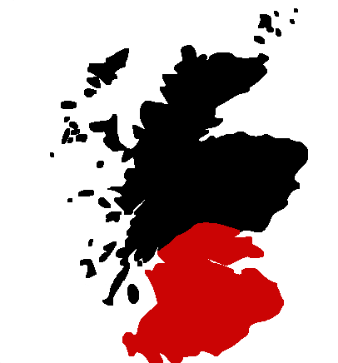
Lowlands

The Lowland region lies south of an imaginary line between Greenock and Dundee. From more than 200 distilleries in the late 19th century, nowadays only a handful are still operating.
Lowland Malts are generally lighter in body and flavour than their counterparts from other regions. They tend to be gentle and subtle, fragrant with herbal and grassy flavours and usually have a relatively dry finish. Since they are not, or only slightly, peated they are an excellent choice for beginners.

Malt | Age/Year |  | Price
Auchentoshan | 21yr |  | £40.00
Auchentoshan 3-Wood |  |  | £12.00
Auchentoshan | 12yr |  | £10.00
Bladnoch | 8yr |  | £12.00
Dumbarton  Cadenheads – Chairmans Stock | 1969 |  | £33.00
Glen Flagler Limited  Glenkinchie Distiller's Edition AM | 1973  1996 |  | £220.00  £14.00
Glenkinchie | 12yr |  | £10.00
Killyloch | 1967 |  | £250.00
Kinclaith  Duncan Taylor – Rarest of the Rare | 35yr |  | £230.00
Ladyburn | 1973 |  | £175.00
Linlithgow  Signatory – Silent Stills | 1975 |  | £35.00
Littlemill Limited | 12yr |  | £30.00
Rosebank Limited  Rare Malts Collection | 20yr |  | £220.00
Rosebank Limited  Flora & Fauna Edition | 12yr |  | £25.00
St. Magdalene  Gordon & MacPhail – Rare old | 1975 |  | £40.00

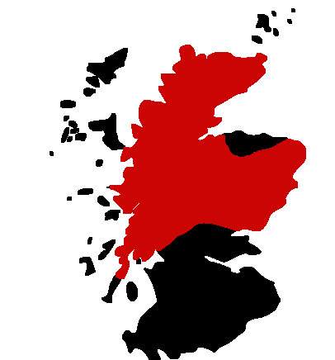
Highlands

The Highlands cover more than half of Scotland and the landscape, with all its lakes and mountains, is world famous.
While malts from the northern Highlands are more salty with notes of seaweed, the whiskies from the east are dryer with more body and a little smokiness and their counterparts from Perthshire are cleaner, lighter and sweeter.

Malt | Age/Year |  | Price
Aberfeldy | 12yr |  | £10.00
anCnoc | 12yr |  | £9.00
Ardmore | 1990 |  | £12.00
Balblair | 2002/03 |  | £12.00
Ballechin #1 Burgundy Wood |  |  | £17.00
Ballechin #2 Madeira Wood |  |  | £17.00
Banff  Gordon & MacPhail – Connoisseurs Choice | 1976 |  | £50.00
Ben Nevis | 10yr |  | £10.00
Ben Wyvis Limited | 37yr |  | £300.00
Ben Wyvis Limited | 27yr |  | £250.00
Blair Athol  Flora & Fauna Edition | 12yr |  | £12.00
Brora  Gordon & MacPhail – Connoisseurs Choice | 1982 |  | £42.00
Clynelish | 14yr |  | £12.00
Dallas Dhu | 1982 |  | £25.00
Dalmore | 12yr |  | £11.00
Dalwhinnie Distiller's Edition | 1992/95 |  | £15.00
Dalwhinnie | 15yr |  | £12.00
Deanston | 12yr |  | £9.00
Edradour | 10yr |  | £11.00
Fettercairn Fior |  |  | £12.00
Glen Albyn 1976 | 1976 |  | £45.00
Glen Deveron | 10yr |  | £10.00
Glen Garioch | 12yr |  | £10.00
Glen Mhor | 1969 |  | £70.00
Glen Moray | 16yr |  | £12.00
Glen Ord | 28yr |  | £52.50
Glencadam | 15yr |  | £12.00
Glencadam | 10yr |  | £9.00
Glencadam  Glendronach | 1987  12yr |  | £10.00  £11.00
Glendronach Revival | 15yr |  | £15.00
Glenesk  Gordon & MacPhail – Connoisseurs Choice | 1985 |  | £21.00
Glenglassaugh Limited  Gordon & MacPhail – Connoisseurs Choice | 1983/86 |  | £45.00
Glengoyne | 18yr |  | £18.00
Glengoyne | 10yr |  | £9.00
Glenlochy  Gordon & MacPhail – Connoisseurs Choice | 1977 |  | £65.00
Glenmorangie | 1963 |  | £295.00
Glenmorangie Margaux Finish | 1987 |  | £95.00
Glenmorangie | 25yr |  | £70.00
Glenmorangie | 18yr |  | £25.00
Glenmorangie Signet |  |  | £38.00
Glenmorangie Nectar d'Or | 12yr |  | £12.00
Glenmorangie Lasanta | 12yr |  | £12.00
Glenmorangie Original | 10yr |  | £10.00
Glenturret | 10yr |  | £8.50
Glenugie  Gordon & MacPhail – Connoisseurs Choice | 1967 |  | £95.00
Glenury Royal  Rare Malts Collection | 29yr |  | £115.00
Glenury Royal Limited  Rare Malts Collection | 23yr |  | £100.00
Hillside  Rare Malts Collection | 25yr |  | £105.00
Inchmurrin | 12yr |  | £10.00
Loch Lomond | 18yr |  | £20.00
Lochside  Gordon & MacPhail – Connoisseurs Choice | 1991 |  | £14.00
Macduff  Gordon & MacPhail – Connoisseurs Choice | 1989 |  | £14.00
Millburn  Rare Malts Collection | 1975 |  | £120.00
Millburn  Gordon & MacPhail – Connoisseurs Choice | 1974 |  | £130.00
North Port-Brechin  Gordon & MacPhail – Connoisseurs Choice | 1981 |  | £70.00
Oban Distiller's Edition MF | 1995 |  | £20.00
Oban | 14yr |  | £12.50
Old Pulteney | 12yr |  | £9.50
Old Rhoshdu Limited | 1967 |  | £47.00
Ord  Cadenheads – Authentic Collection | 11yr |  | £14.00
Royal Brackla  Gordon & MacPhail – Connoisseurs Choice | 1997 |  | £15.00
Royal Brackla |  |  | £11.00
Royal Lochnagar | 12yr |  | £10.00
Speyburn | 10yr |  | £9.00
Stronachie | 12yr |  | £10.00
Teaninich  Flora & Fauna Edition | 10yr |  | £12.00
Tomatin | 12yr |  | £9.00
Tullibardine | 1964 |  | £90.00
Tullibardine | 1973 |  | £40.00
Tullibardine | 1988 |  | £17.00
Tullibardine Pedro Ximenez Finish | 1993 |  | £15.00
Tullibardine Banyuls Finish |  |  | £12.00
Tullibardine | 1993 |  | £15.00

“There are two things a Highlander likes naked, and one of them is malt whisky.”

Scottish proverb

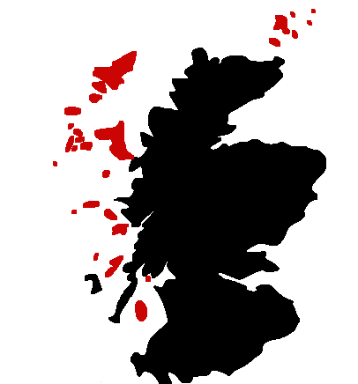
Islands

Strictly speaking the islands belong to the highland region, but are sometimes referred to as a region of its own simply by geographical reasons. The island region includes all Scottish islands except Islay.

Island malts are hard to define since they all have their own individual style. Most of them are peated but less so than the malts from Islay and they are generally complex and powerful drinks, with spicy and seaweed notes.

Arran
Malt | Age/Year |  | Price
Arran | 10yr |  | £11.00
Jura
Malt | Age/Year |  | Price
Isle of Jura | 10yr |  | £10.00

Lewis
Malt | Age/Year |  | Price
Abhainn Dearg First Bottling | 2008 |  | £52.00

Mull
Malt | Age/Year |  | Price
Tobermory | 10yr |  | £11.00
Ledaig | 10yr |  | £10.00

Orkney
Malt | Age/Year |  | Price
Highland Park Limited | 40yr |  | £375.00
Highland Park | 25yr |  | £50.00
Highland Park | 21yr |  | £40.00
Highland Park | 18yr |  | £20.00
Highland Park | 12yr |  | £10.00
Highland Park Ice |  |  | £80.00
Scapa Skiren |  |  | £14.00

Skye
Malt | Age/Year |  | Price
Talisker Distiller's Edition | 1999 |  | £20.00
Talisker | 10yr |  | £11.00

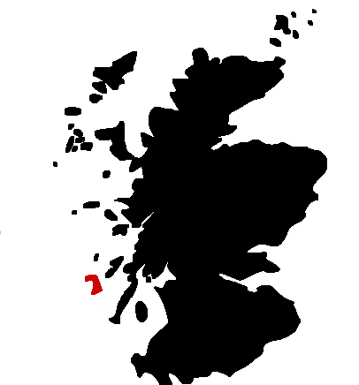
Islay

Known as “The Queen of the Hebrides” Islay is the southernmost island of the Inner Hebrides and is home to eight working distilleries.
Islay Malts are very easy to identify. Heavily peated, very pungent with notes of salt and seaweed on the palate, they sometimes seem to be more of a medicine than a whisky. These Malts are equally loved and hated by whisky enthusiasts all over the world.

Malt | Age/Year |  | Price
Ardbeg Supernova Limited |  |  | £52.00
Ardbeg Airigh Nam Beist Limited | 1990 |  | £50.00
Ardbeg Ardbog Limited |  |  | £30.00
Ardbeg Uigeadail |  |  | £16.00
Ardbeg | 10yr |  | £12.00
Bowmore | 25yr |  | £60.00
Bowmore | 18yr |  | £19.00
Bowmore Darkest | 15yr |  | £15.00
Bowmore | 12yr |  | £10.00
Bruichladdich Black Art |  |  | £58.00
Bruichladdich Islay Barley |  |  | £12.00
Bruichladdich Laddie Ten |  |  | £10.00
Bunnahabhain | 18yr |  | £18.00
Bunnahabhain | 12yr |  | £9.00
Caol Ila | 18yr |  | £18.00
Caol Ila | 12yr |  | £11.00
Kilchoman Bourbon Cask |  |  | £25.00
Lagavulin Distiller's Edition PX | 1995 |  | £18.00
Lagavulin | 16yr |  | £14.00
Laphroiag Lore |  |  | £28.00
Laphroaig Triple Wood |  |  | £15.00
Laphroaig | 10yr |  | £10.00
Port Charlotte – PC7 | 7y |  | £18.50
Octomore | 5yr |  | £22.00

“Whisky has made us what we are. It goes with our climate and with our nature. It rekindles old fires in us, our hatred of cant and privilege, our conviviality, our sense of nationhood, and above all, our love of Scotland.”

Sir Robert Hamilton Bruce Lockhart, 1959.

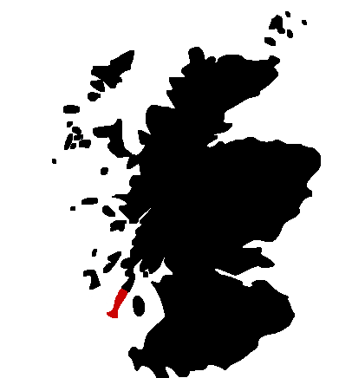
Campbeltown

Before Prohibition started in the US, Campbeltown was home to more than 30 distilleries. Its location made in the ideal place to produce whisky for shipping across the ocean. But with alcohol becoming illegal in the States in 1920, the distilleries in Campbeltown started dying and today there are less than a handful still in production. The malts tend to be dry, full bodied with a distinct smokiness and salty notes.

Malt | Age/Year |  | Price
Glen Scotia | 12yr |  | £18.00
Hazelburn | 8yr |  | £15.00
Kilkerran “Work in Progress” | 5yr |  | £10.00
Longrow | 10yr |  | £12.00
Springbank | 10yr |  | £12.50

“There are two rules for drinking whisky. First never take whisky without water, and second never take water without whisky!”

Chic Murray, 1977.

Blended Scotch Whisky

Whisky | Age/Year |  | Price

Johnnie Walker Blue |  |  | £65.00
Johnnie Walker Gold Label | 18yr |  | £14.00
Johnnie Walker Black Label | 12yr |  | £7.50
Chivas Regal | 18yr |  | £14.00
The Antiquary Limited | 21yr |  | £20.00
The Antiquary | 12yr |  | £7.50
Chivas Regal | 12yr |  | £7.50
Alfred Dunhill Old Master Blend |  |  | £6.50
Wemyss Spice King |  |  | £6.50
Famous Grouse |  |  | £6.50
Snow Grouse |  |  | £7.50
Famous Grouse Mellow Gold |  |  | £7.50
Naked Grouse |  |  | £8.50

Blended Malt Scotch Whisky

Whisky | Age/Year |  | Price

Monkey Shoulder |  |  | £7.50
Compass Box Oak Cross |  |  | £6.50

Single Grain Scotch Whisky

Whisky | Age/Year |  | Price

Cameron Brig Limited | 28y |  | £14.00
Cameron Brig |  |  | £6.50
Haig Club £12.00

“Officer I know the driver of the car that hit me.
His name is Johnnie Walker.”

From the movie "A Beautiful Mind"

Whiskies from across the world

We are also delighted to offer you a choice of whiskies from other parts of the world. Some of these whiskies are made from different ingredients than Scotch whisky, which gives them their own special character.

Ireland

Whiskey | Age/Year |  | Price
Bushmills Single Malt | 10yr |  | £6.50
Bushmills |  |  | £6.50
Jameson |  |  | £6.50

Wales

Whisky |  |  | Price
Penderyn Sherry Wood |  |  | £10.00

Sweden

Whisky |  | ABV | Price
Mackmyra Preludium 03 |  | 52.2 | £25.00

India

Whisky |  |  | Price
Amrut |  |  | £7.50

Japan

Whisky | Age/Year |  | Price
Nikka from the Barrel | 10yr |  | £10.00

United States of America

Kentucky

Whiskey |  |  | Price
Woodford Reserve |  |  | £8.00
Jim Beam White Label |  |  | £7.50
Jim Beam Rye |  |  | £12.00
Maker's Mark |  |  | £7.50
Four Roses |  |  | £7.50
Buffalo Trace |  |  | £7.50
Evans Williams |  |  | £8.50

Tennessee

Whiskey |  |  | Price
Jack Daniel's Single Barrel |  |  | £10.00
Jack Daniel's Old No. 7 |  |  | £7.50

Canada

Whisky |  |  | Price
Crown Royal |  |  | £9.00
Canadian Club |  |  | £6.50
Seagrams VO |  |  | £6.50

Australia

Whisky |  |  | Price
Larks Single Malt |  |  | £9.00

“How well I remember my first encounter with The Devil's Brew. I happened to stumble across a case of bourbon and went right on stumbling for several days thereafter.”

W.C. Fields

Aperitifs
Campari £7.00
Ricard £7.00
Pernod £7.00
Pimm's No. 1 £8.00

Liqueurs
Amaretto Disaronno Originale £7.00
Bailey’s Irish Cream £5.00
Chambord £7.00
Cointreau £7.00
Cointreau Noir £8.50
Drambuie £7.00
Fernet Branca £7.00
Frangelico £7.00
Glayva £7.00
Grand Marnier £7.00
Grand Marnier Cuvée du Centenaire £12.00
Grand Marnier Cuvée du Cinquantenaire £15.00
Kahlua £7.00
Kümmel £7.00
Limonino Limoncello £7.00
Licor 43 £7.00
Malibu £7.00
Midori £7.00
Sambuca Crystal Puccini £7.00
Sambuca Graphite Puccini £7.00
Southern Comfort £7.00
St Germain £7.00
Tia Maria £7.00

Old Course Hotel
St Andrews

One century in a bottle. Each decanter takes four generations of cellar masters over 100 years to craft.

LOUIS XIII is a blend of up to 1,200 eaux-de-vie, the youngest of which is at least 40 years old, and created exclusively with grapes from Grande Champagne, the most prestigious region of Cognac.

Rich in aromas of myrrh, plum, honey and jasmine with a complex warm, harmonious and spicy palate culminating in an extremely long finish of an hour or more, LOUIS XIII is the King of Cognacs.

FOR THE CONNOISSEURS 50ml £250

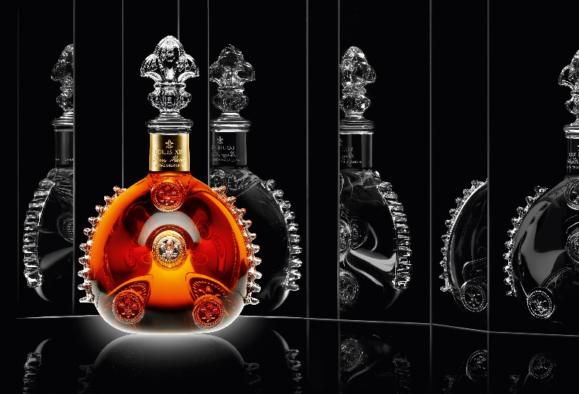

Cognac

Courvoisier
L’Essence £350.00
Initiale £60.00
XO £28.00
Exclusif £12.00

Hennessy
Paradis £70.00
XO £28.00
Fine de Cognac £12.00

Hines
Antique £28.00
Delicate and Rare £12.00

Martell
XO £28.00
Cordon Bleu £21.00
VSOP £12.00
Remy Martin
Louis XIII £250.00
XO £28.00
Cœur de Cognac £12.00
VSOP £12.00

Armagnac
XO Janneau £28.00
VSOP Janneau £12.00

Calvados
Boulard 1982 £20.00
Grand Solage £12.00

Sherry
Pedro Ximenez £6.00
Lustau Fino £6.00
Lustau Palo Cortado £6.00

Port |  | Glass 100ml |  | Bottle 750ml
Taylor's LBV | £7.50 |  | £42.00
Taylor's Tawny 10 years | £9.00 |  | £55.00
Taylor's Tawny 20 years | £17.00 |  | £90.00

Vermouth
Martini Extra Dry £6.00
Martini Bianco £6.00
Martini Rosso £6.00
Noilly Prat £6.00
Gin
Botanist, Scottish £8.00
Caorunn, Scottish £8.00
Eden Mill Gin, Scottish £8.50
Eden Golf Gin, Scottish £9.00
Gin Bothy Gunshot, Scottish £8.25
Gin Bothy Chilli, Scottish £8.25
Hendrick's, Scottish £8.00
Monkey 47, German £12.00
No 3, Dutch £9.00
Rock Rose, Scottish £8.00
Strathearn Highland Oak, Scottish £8.50
Tanqueray, Scottish £8.00
Tanqueray No. 10, Scottish £9.00
Bombay Sapphire, English £8.00
The Star of Bombay, English £9.00

Genever
Bols Genever, Dutch £9.75

Vodka
Belvedere, Polish £8.50
Cîroc, French £9.00
Grey Goose, French £8.50
Ketel One, Dutch £8.00
Stolichnaya, Russian £8.00
Stolichnaya Elit, Russian £9.00
Titos, American £8.00
Zubrowska, Polish £8.00

Rum
Brugal Blanco, Dominican £6.50
Brugal Anejo, Dominican £7.00
Brugal 1888, Dominican £12.00
Brugal XV, Dominican £8.50
Dark Matter, Scottish £8.00
Diplomatico Reserva Exclusive, Venezuelan £9.50
Gosling’s Black Seal, Bermuda £8.00
Black Kraken Spiced Rum, Caribbean £8.00
Havana 7, Cuban £8.00
Santa Teresa 1796, Venezuelan £10.50
Ron Zacapa 23, Gautamalan £15.00

Cachaça
Sagatiba Velha £9.00
Sagatiba Pura £7.30

Tequila
Ocho Extra Anejo £22.50
Ocho Anejo £13.50
Don Julio Blanco £10.00
Don Julio Anejo £12.00

Mezcal
Del Maguey Crema £10.00

Scottish Beers
St. Andrews Ale £5.75
Eden Brewery Blonde £5.25
Eden Brewery Clock Brew £5.25
Eden Brewery 19th £5.25
Innis & Gunn Original £5.25
Brewdog Vagabond - Gluten Free £5.25
Harviestoun Schiehallion £5.25
Brewdog Nanny State Non-Alcoholic £4.00
Joker IPA £5.25
Dark Island Ale £5.75

Beers from around the world
Budweiser £4.30
Nastro Azurro Peroni £4.40
Guinness £4.70
Budvar £4.30
Corona £4.20
Stella £4.30
Heineken £4.00

Cider
Kopperberg £5.25

Mineral Water

Highland Spring Still or Sparkling Water
Bottle 330ml - £1.95 Bottle 750ml - £4.00

Juices

Orange, Grapefruit, Apple, Cranberry, Pineapple, Tomato
£2.50

Soft Drinks & Mixers

Coca Cola & Diet Coke £2.50
Lemonade & Soda £2.00
Irn Bru & Appletiser £2.50
Fentamins Ginger Beer, Ginger Ale, White Elderflower &
Mandarin and Seville Orange £3.50

“Beer is proof that god loves us and wants us to be happy.”

Benjamin Franklin

Hot Beverages

Coffee
Espresso, Macchiato £3.00
Double Espresso £3.50
Cappuccino, Latte, Mocha, Americano £4.00

TLC Tea Range
Breakfast, Earl Grey, Darjeeling, Decaffeinated, Lemon & Ginger, Red Bush, Raspberry & Elderflower, Assam, Green, Peppermint, Chamomile , Rose £4.00

Other Hot Drinks
Hot Toddy £8.00
Liqueur Coffee £8.00
Hot Chocolate £4.25

“Only Irish coffee provides in a single glass all four essential food groups: alcohol, caffeine, sugar, and fat.”

Alex Levine
Cigars

Please note that due to the smoking ban in Scotland, smoking is strictly prohibited within these premises.
You can enjoy your cigar on our West Deck.

Cohiba Esplendido £62.00
Cohiba Robusto £48.00
Monte Cristo No.2 £45.00

Monte Cristo No.4 £26.00
Bolivar No. 1 £30.00

Bolivar No 3 £17.00

Partagas No 4 £34.00

Romeo y Julietta No 2 £26.00

Romeo y Julietta No 3 £30.00

Romeo y Julitea Short Churchill £36.00

Cohiba Panatella £19.00
Punch Petit Coronations £19.00

Punch Punch £35.00

Villager Export Gepresst £7.50

“My rule of life prescribed as an absolutely sacred rite smoking cigars and also the drinking of alcohol before, after and if need be during all meals and in the intervals between them.”

Sir Winston Churchill
Opening times and General Information
Open from 11:00am, 7 days.

Under 18’s welcome.
The closing time of The Road Hole Bar is at the discretion of the bar team. Last orders will be called 15 minutes prior to closing.
Due to Scottish licensing we may only accommodate
Non-residential guests until 1am.

In accordance with the Weights and Measures Act of 1985,
the measure for the sale of gin, rum, vodka and whisky
in the Road Hole Bar is 50ml or multiples thereof.
Wines by the glass are served at measure of 125ml.

All prices include V.A.T. at 20%.

The Old Course Hotel, Golf Resort & Spa
St. Andrews, Fife KY16 9SP
01334 474371
reservations@oldcoursehotel.co.uk

