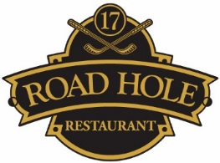

Sunday Lunch Menu
Starter
Spiced Cauliflower Soup, toasted almonds
Whipped Goats Cheese, roasted beetroots, rocket, Balsamic & honey dressing
Pressed Ham Hough Terrine, piccalilli & toasted brioche

Main Course
Roast Rib of Scotch Beef, roast potato, roast vegetables & Yorkshire pudding
Fillet of Loch Awe Sea Trout, cockle risotto, samphire, parsley & coriander oil
Tomato & Clava Brie Tart, grape chutney & garden salad

Dessert
Macerated Strawberries, cracked black pepper cream, strawberry sorbet & butter tuille
Dulcey Chocolate Parfait, pistachio & raspberry sorbet

Selection of Scottish Cheeses
(£2.00 Supplement)

Three Course Lunch £22.50
Add a glass of Prosecco £28.50

