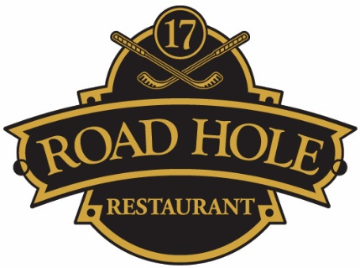

Crustacea
Kyle of Tongue Oysters, homemade shallot vinegar, lemon | £16.50
Dressed Crab, green salad, lemon | £16.50
Scottish West Coast Langoustines, garlic mayonnaise | £45.00
St. Andrews Bay Half Lobster, fennel & orange salad | £38.50
Plateau de Fruits de Mer, (for two), two St. Andrews bay half lobster, four Kyle of Tongue oysters, dressed crab, cockles, four langoustines, four hand dived scallops, six mussels, garlic mayonnaise, shallot vinegar | £155.00
Starters
Twice Baked Anster Cheese Soufflé, beetroots and arugula | £7.00
St. Andrews Bay Lobster Bisque, aioli, crostini | £9.50
Charred Mackerel Tartare, horseradish, cucumber | £12.00
Foie Gras Ballantine, peppered pineapple, chilli & brioche | £12.75
Scottish West Coast Langoustine salad, Stornoway black pudding, pork crackling | £16.75
Scottish West Coast Hand Dived Scallops, white bean purée, cauliflower, chorizo & apple | £16.50
St. Andrews Bay Lobster Salad, confit fennel & orange | £19.50

Butternut Squash & Chickpeas Pithivier, kohlrabi, tahini, pickled cucumber | £15.50
Pan Roasted Loch Awe Sea Trout, asparagus, garlic, garden peas & Arenkha caviar | £19.75
Pan Fried Skate Wing, langoustine, mushrooms, baby leeks | £20.50
North Atlantic Halibut, cockle risotto, samphire, parsley oil, coriander | £21.25
Grey Sole fillet, crab, crushed jersey royal potatoes, sauce Grenoble | £21.95
Herb Crusted Scottish Lamb Loin, braised lamb shoulder aubergine purée & courgette | £26.50
8oz Scottish black Isle Beef Rib Eye, pont-neuf potatoes, vine tomatoes, Portobello mushroom | £32.00
8oz Scottish Fillet Steak, pont-neuf potatoes, vine tomatoes, Portobello mushroom | £35.00
Surf and Turf (for two), rib eye chop, two half St. Andrews Bay lobster, pont-neuf potatoes, vine tomatoes, Portobello mushroom | £100.00
Side Orders
Red Wine Jus | £2.25
Blue Cheese Sauce | £2.95
Peppercorn Sauce | £2.95
Béarnaise Sauce | £2.95
Baby Boiled New Potatoes | £3.00
Gratin Dauphinoise | £3.00
Market vegetables | £3.00
Skinny Fries | £3.00
Road Hole Restaurant Salad | £3.75

Mains

