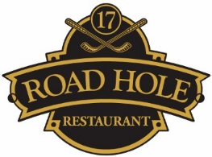

Dessert Menu

Liquorice Panna Cotta, strawberry sorbet, coconut foam, lime
£8.50
Araguani Chocolate Mousse, basil oil, olive oil sponge, raspberry sorbet
£8.50
Frozen Tonka Bean Parfait, cherry blossom crèmeux, compressed apricot
£8.50
Bayleaf Custard, poached rhubarb, hazelnut crumble
£8.50
Lemon Meringue Soufflé, yoghurt sorbet, lemon jelly
£9.50
Selection of Artisan cheeses, truffle honey, black grapes
£12.50

