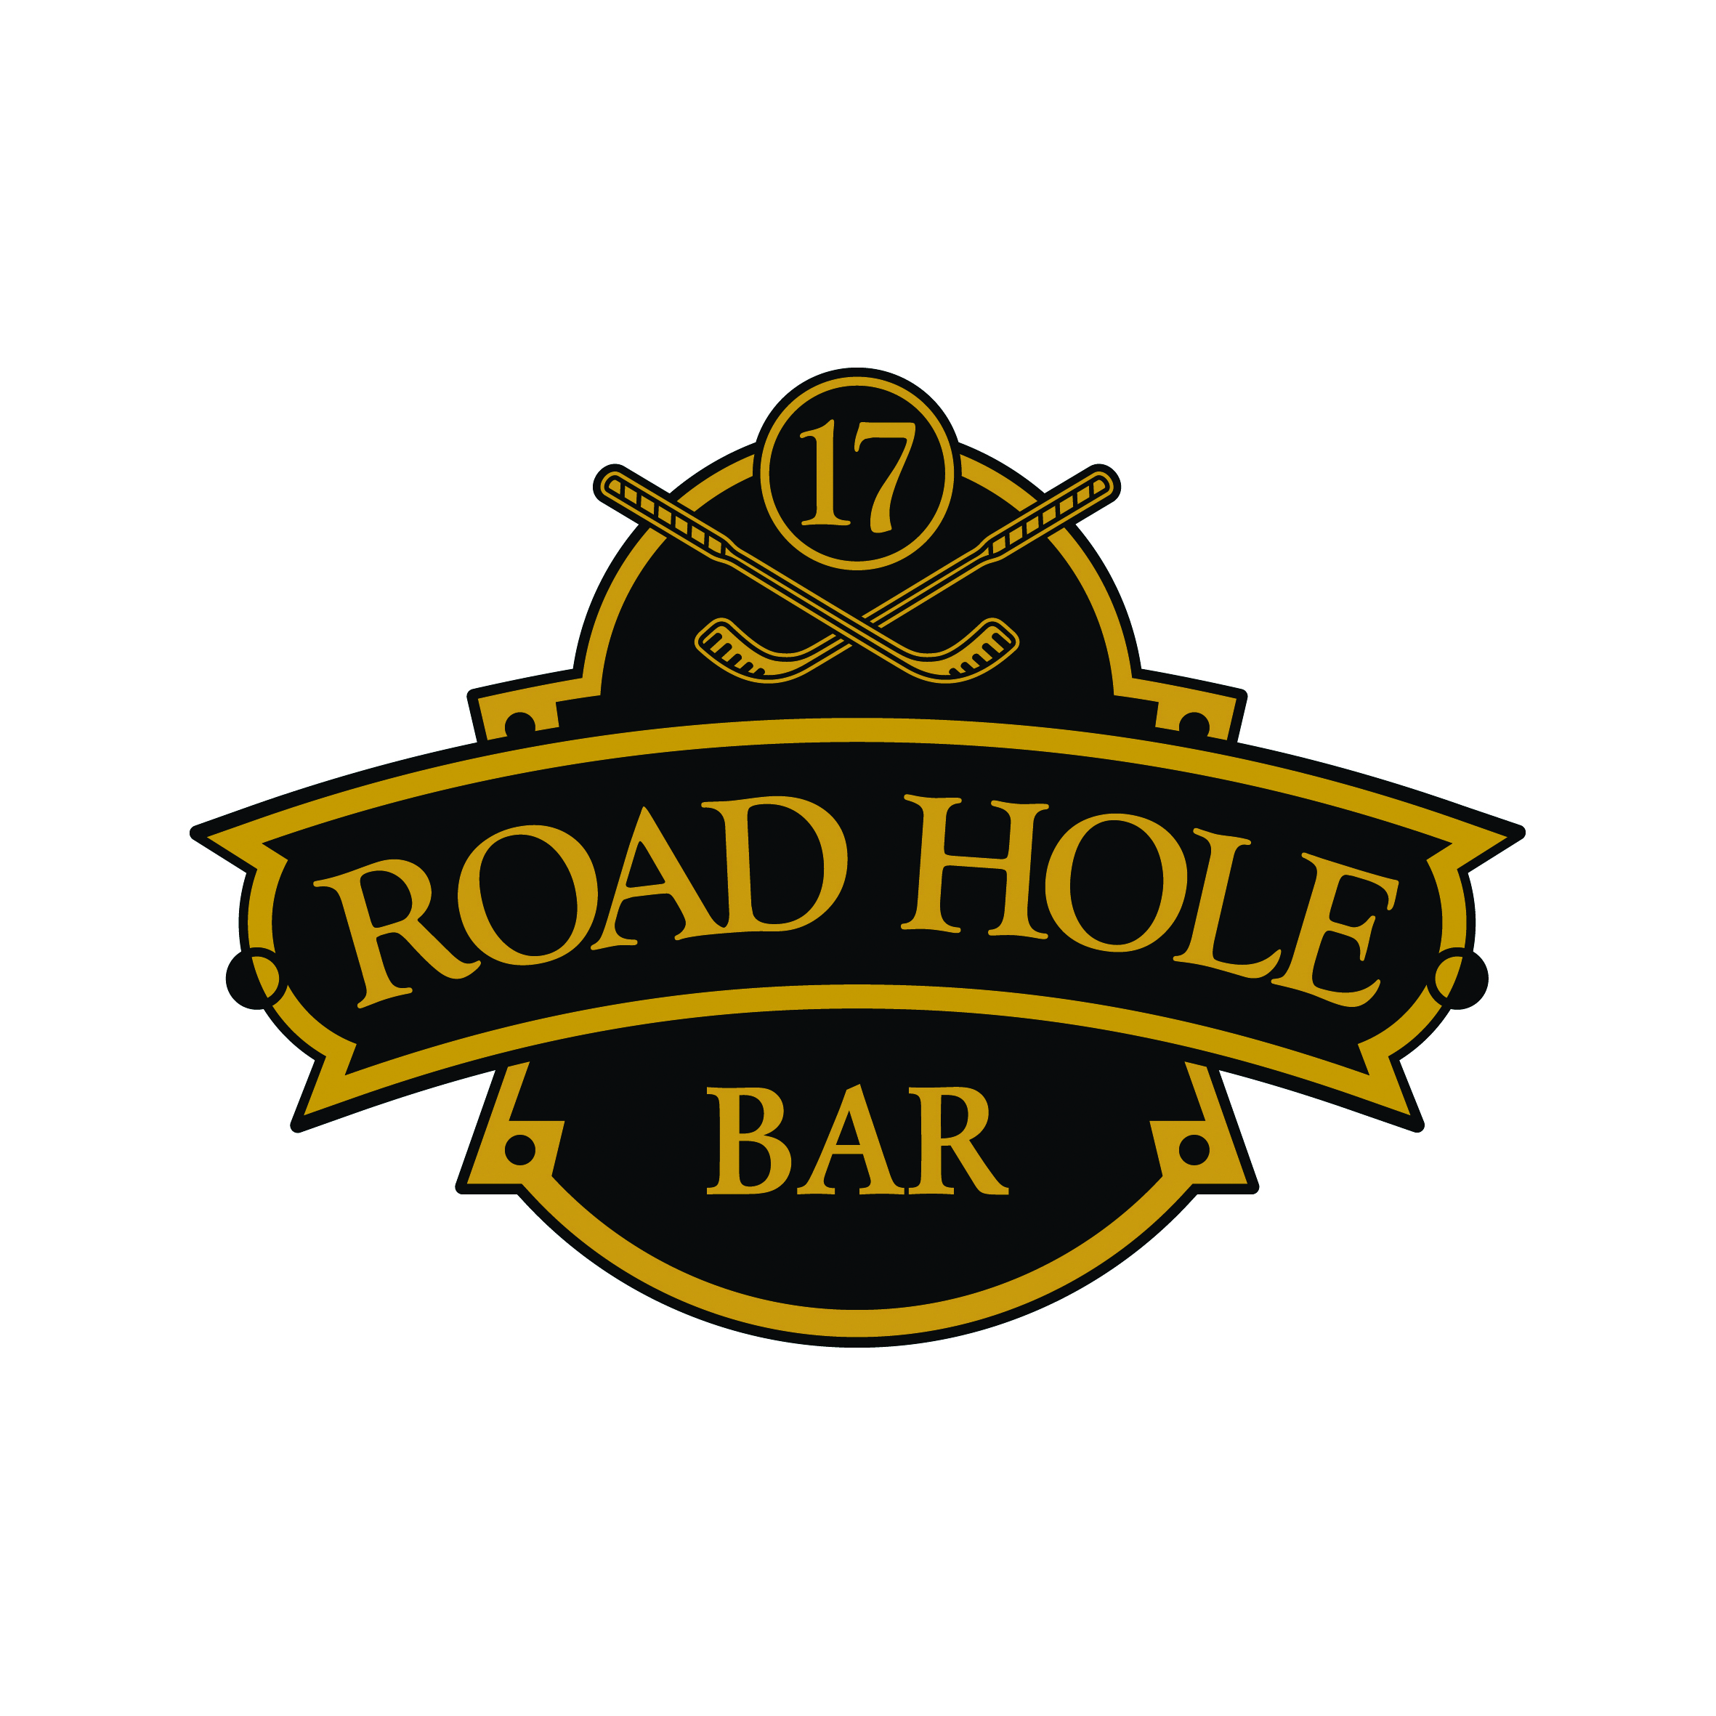
Sandwiches |  | Salads
Smoked salmon wrap, garlic & chive cream cheese rocket salad  £10.95 |  | Baby gem lettuce, Caesar dressing, anchovies, parmesan shavings  £7.95  With char grilled chicken  £9.50
Honey glazed ham & tomato  sandwich  £7.50 |  | Gambas, watermelon, Parma ham, & balsamic dressing salad  £9.50
Mull Cheddar & tomato salsa sandwich
£7.50
Free range egg & cress sandwich  £7.50 |  | Desserts
Club Sandwich  Served on grilled artic bread  £10.95 |  | Selection of Cheeses  £8.50
Sticky toffee pudding
£6.50
Baked vanilla cheesecake,
cherry compot, pistachio ice cream
£6.50

Whisky & tablet sundae
£7.50

