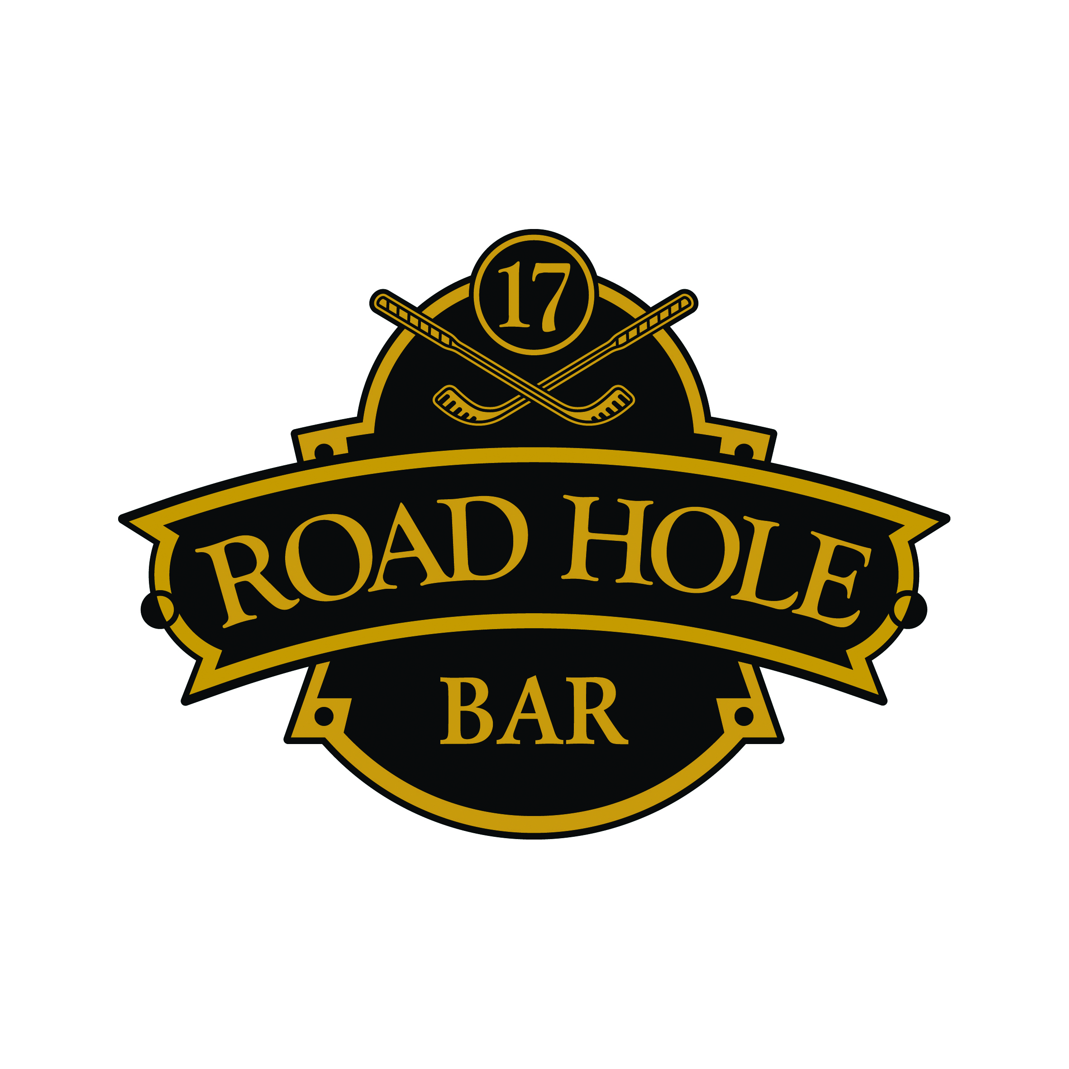
Lunch Menu
Served 11am – 5pm

Salads
Caesar Salad, anchovies & parmesan shavings | £7.95
- Add char grilled chicken | £9.50
Butternut squash, lime, coriander, peanuts & toasted seed | £8.29
Plum tomatoes, mozzarella, avocado, rocket leaves | £9.50
Smoked mackerel, beetroot, kale & freekah salad | £10.50
Sandwiches
Scottish smoked salmon | £8.50
Cucumber and cream cheese | £5.50
Prawn and dill mayonnaise | £9.50
Honey glazed ham and tomato chutney | £7.50
Free range egg and cress | £7.50
Mull cheddar & heritage tomato | £7.50
Old Course sandwich selection
- One of each sandwich from above | £10.50
Club Sandwich
- Bacon, chicken, lettuce, tomato and egg mayonnaise | £10.95

Mains
St. Andrews beer battered haddock, chips, mushy peas, tartare sauce | £13.95
Old Course burger, beer battered onion rings, fries | £13.95
Fillet of Sea bass, tomato & vegetables risotto | £14.75
Potato Gnocchi, peas, wild mushrooms, goat’s cheese, rocket | £13.95
Desserts
Sticky toffee pudding | £6.50
Whisky & tablet sundae | £7.50
Baked vanilla cheesecake, cherry compot, pistachio ice cream | £6.50
Selection of Scottish cheeses | £8.50
Hot Beverages
Served with Scottish shortbread

Espresso, Double Espresso, Cappuccino, Cafe Latte, Americano,  Mocha or Decaffeinated | £4.00
Selection of Teas | £4.00
Hot Chocolate | £4.00
Liqueur Coffees | £8.00

